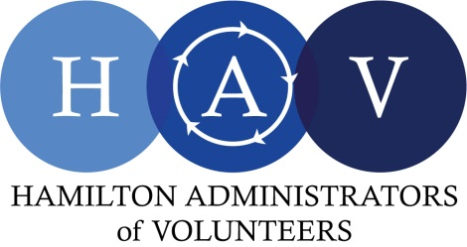

Membership Application / Renewal Form
June 1, 2024 – May 31, 2025

Member Profile

Contact Information
First Name: | Last Name:
Work Phone #: | Work Email:
Job Title: | Organization:
(Optional)  Personal Phone #: | (Optional)  Personal Email:
Organization Volunteer Web Page:
*With your membership we will include a direct link to the volunteer page of your organization’s website, unless otherwise indicated here.

- I consent to share my work contact information with HAV membership on the membership list.
Personal information will never be shared.

Membership Fee Information
□ Annual Individual Fee: $50.00 (early bird rate $40.00 if paid on or before June 14, 2024)
□ Annual Student/Retired/Seeking Employment Fee: $25.00 (early bird rate $20.00 if paid on or before June 14, 2024)
Who is paying for this membership? □ Self □ Organization

*If fees for a general or associate membership are paid by an organization rather than the individual, the membership is transferable to another staff member only if the original member leaves the organization. Memberships paid by individuals follow them if they change their place of employment. Please contact us if a change of employment occurs.

Memberships paid by an organization are not intended to be transferable between staff at an organization for ongoing purposes throughout the year. If more than one staff member at an organization is interested in joining HAV, each of them requires their own membership.

Please return this completed membership form with payment to:

By e-transfer: Send payment to hamiltonadvolunteers@gmail.com.
Please return this completed membership form by email and advise that e-transfer was completed.
OR
By cheque: Hamilton Administrators of Volunteers, 762 Upper James St., Suite 183 Hamilton, ON L9C 3A2

